Entire below notes is based on Hibernate 3.5 and Java Persistence 2.0
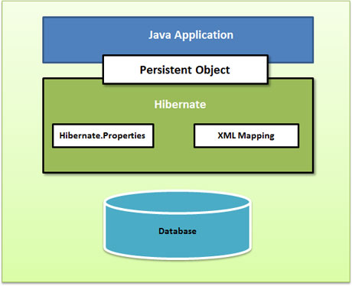

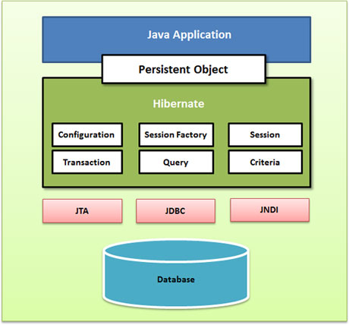
Annotations can be split in two categories,
1) Physical mapping annotations (describing the physical schema, tables, columns, indexes, etc).
2) The logical mapping annotations (describing the object model, the association between two entities etc.)
@Entity --- specifies the class is hibernate mapping class.
@Table --- optional
@Id --- primary key specification
@Id @GeneratedValue(strategy=GenerationType.SEQUENCE, generator="SEQ_STORE")// generate the sequence from sql
public Integer getId() { ... }

- not annotated at all
- annotated with @Basic
- annotated with @Version// optimistic lock
- annotated with @Lob
- annotated with @Temporal

@Lob indicates that the property should be persisted in a Blob or a Clob depending on the property
Use the @Temporal annotation to fine tune Temporal data like DATE, TIME, orTIMESTAMP precision (ie the actual date, only the time, or both)
The @Basic annotation allows you to declare the fetching strategy for a property: either eager or lazy…
@Basic(fetch = FetchType.LAZY)
Address address; // persistent property

Embedded Objects also known as Components

Fields of an embeddable type default to persistent, as if annotated with @Embedded.
@Embeddable
@Access(AcessType.PROPERTY)
public class Address {
private String street1;
public String getStreet1() { return street1; }
public void setStreet1() { this.street1 = street1; }

private hashCode; //not persistent
}
@Entity
public class User {
private Long id;
@Id public Long getId() { return id; }
public void setId(Long id) { this.id = id; }

private Address address;
@Embedded public Address getAddress() { return address; }
public void setAddress() { this.address = address; }
}

@column----
@Column(updatable = false, name = "flight_name", nullable = false, length=50)
public String getName() { ... }

@Column(
name="columnName";
boolean unique() default false;
boolean nullable() default true;
boolean insertable() default true;
boolean updatable() default true;
String columnDefinition() default "";
String table() default "";
int length () default 255;
int precision() default 0; // decimal precision
int scale() default 0; // decimal scale

1) Build the session factory using AnnotationConfiguration rather than Configuration
sessionFactory = new AnnotationConfiguration()
.configure().buildSessionFactory();

Logging
Hibernate Annotations utilizes Simple Logging Facade for Java (SLF4J) in order to log various system events. In order to setup logging properly you will need slf4j-api.jar in your classpath together with the jar file for your preferred binding - slf4j-log4j12.jar in the case of Log4J.

Hibernate has been bought by JBOSS and JBOSS has been bought by RedHat.

